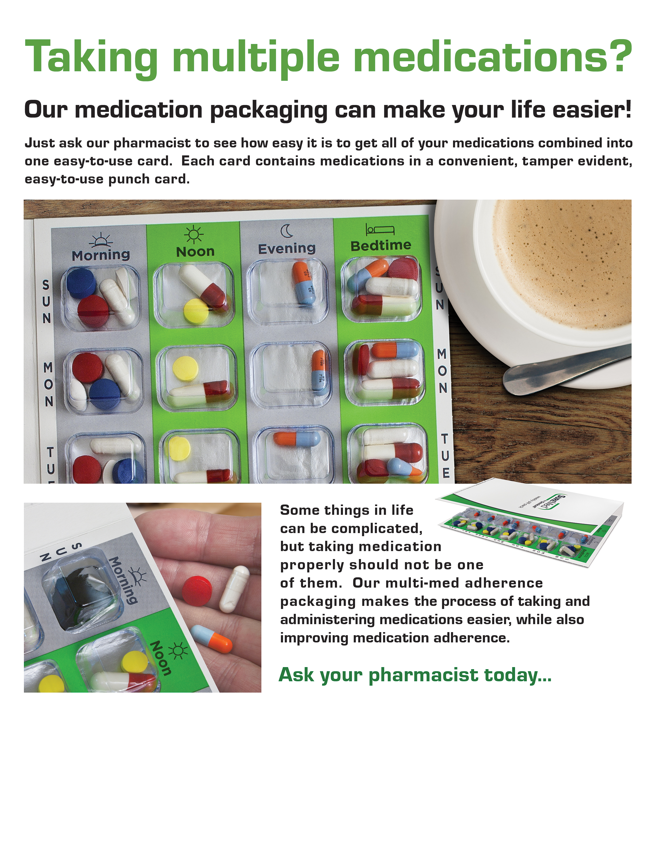
Please add pharmacy logo, address, phone numbers or any other pharmacy information in this section. You can add extra text boxes to insert additional text and you can also remove the black boarder if you wish…

